Taiji Camp at Hesselberg from 03.09. til 10.09.2023

Dear Taiji practitioners,

We are very happy that Wee Kee Jin will be teaching regularly in Hesselberg again.

We hereby cordially invite you to the one-week Taiji seminar with him in Hesselberg.

The workshop program includes the Five Relaxing Movements by Huang Sheng Shyan, Taiji forms and partner work. Wee Kee Jin conveys many small details that can give us a completely new awareness of the inner and outer movement of Taiji.
Beginners in the Huang system are also welcome. Hella will assist again.

Early registration helps the organization a lot. That's why this time there is an early bird discount if you register by July 10th, 2023. Unfortunately, the house charges a hall rent of 1800 €, which results in 60 € hall rent for 30 participants. With more participants it becomes less.

The workshop begins on Sunday with dinner and ends on the following Sunday with lunch.

Timetable:

6.00 – 7.00 Free Training

7:00 – 8:00 Free Pushing Hands

8:00 Breakfast

9:30 – 11:30 Lessons

12:00 Lunch

16:00 – 18:00 Lessons

18:00 Dinner

19:00 – 21:00 Lessons

We need a filled and signed registration form from each participant! Please send this to Hella via e-mail: hella@taiji-schule-os.de
or by post: Hella Ebel, Natruper Strasse 6, 49076 Osnabrück

Location of the Evangelical Education Center and how to get to the Hesselberg:

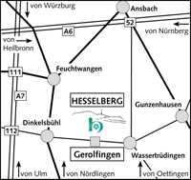 | 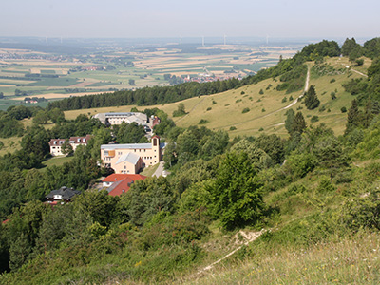
The Evangelical Education Center is in a secluded location on the Hesselberg. The adress is:

Evang. Bildungszentrum Hesselberg
Hesselbergstr. 26
91726 Gerolfingen

There is a day café and an indoor pool in the complex. The indoor pool can be used free of charge by course participants.
At 689 m, the Hesselberg is the highest peak in Middle Franconia. As a witness of the Franconian Jura mountain Hesselberg is the geographic center between the Romantic Road, the New Franconian Lake District, Nördlinger Ries and the rococo town of Ansbach.
Arrival by car: A6 exit 52 (Ansbach/Wassertrüdingen)
A7 exits 111 (Feuchtwangen) or 112 (Dinkelsbühl)
Then orient yourself towards the towns of Wassertrüdingen and Dinkelsbühl.
The training center is located above the village of Gerolfingen.
The way up to Hesselberg is only possible from there.
In Gerolfingen - on the state road 2218 between Wassertrüdingen in the east and Dinkelsbühl in the west - clear signs point the way to the Evang. Education Centre. There is no direct connection by public traffic. The nearest train station is Gunzenhausen.
It is possible to be picked up from the Evangelical Education Center at Gunzenhausen train station for 12€. If necessary, please contact the training center in advance.

Further information on the Evangelisches Bildungszentrum Hesselberg can be found on the following page: https://ebz-hesselberg.de

Registration form

I hereby register for the Taiji workshop with Wee Kee Jin from September 3rd to September 10th of 2023 at Evangelisches Bildungszentrum Hesselberg.

Surname | First name
Street, house number | Postal Code, city
Telephone | E-mail

I have the following room request:
Full board single room with shower/toilet: 82,85€/day - 579,95€/week
Full board double room with shower/toilet: 77,15€/day – 540,05€/week per person
Name of the room partner if you wish to have a double room:

Meals |  | vegetarian |  |  | meat

The course fee for the lessons is: |  | €

For a shorter participation of the workshop, 14 € per lesson (with 6 lessons/day to be paid) will be charged.

A fee of 5 € is required for an individual billing of the accommodation for the tax office.

An early booking discount is only available with a binding registration (signed) and a transfer of €60 for the hall rental by July 10th, 2023 to the following bank account:
Hella Ebel
IBAN: IBAN: DE75 2659 0025 0309 3727 00
BIC: GENODEF1OSV
Early bird 440€ course fee later 480€
Registration is possible until August 18th, 2023.

I take part in the workshop on my own responsibility and in good health. No liability is provided in the event of accidents. Attendees participate on their own risks.

Place, date | Signature

