***6th Osnabrück Pushing Hands - Meeting***

03.10. - 06.10.2024

Thursday, Friday, Saturday and Sunday

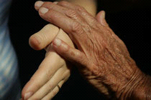

Dear Taiji Practitioners

After the wonderful experiences of the exchange about the free partner work since 2018, I cordially invite you to this year's 4-day TAIJI Pushing Hands meeting with

**Roland von Loefen, Thomas Kirchner and Hella Ebel**

The Taiji school with the rooms in the Aikido school Osnabrück offers the spatial conditions for a meeting. Our Huang system includes a conscious approach through the many different fixed partner exercises and the semi-free pushing. Alternating in a V-step, parallel stance and arch step make it easier to work with inner, relaxed strength.

*An event organized by the Tai Chi School Osnabrück and the Federal Association for Taijiquan and Qigong Germany e.V.*

 

It has been shown that it is no problem for Taiji practitioners (who have little or no experience in free pushing hands) to participate. All the advanced practitioners were very considerate with the beginners.

***This meeting is not suitable for fighting or for training for competitions.***

The motto of this event is:

To apply and better understand the classic writings of TAIJI (TAICHI).

**Pushing - Hands** develops the internal qualities of the five elements

these are:

- stick - connect - stick - follow - don't resist and don't loosen the connection

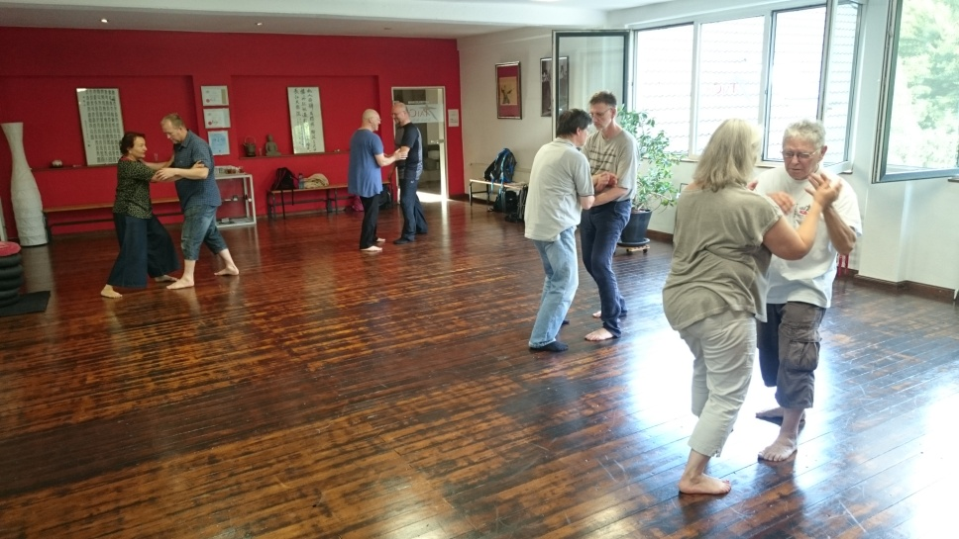

|  |
| --- |
| **Thursday Friday Saturday Sunday** |
| **9:30-10:00 9:30-10:00 9:30-10:00 9:30-10:00** |
| **5 relaxation exercises with Hella** |
|  |
| **10:00 – 11:45 10:00 – 11:45 10:00 – 11:45 10:00 – 11:45** |
| **Fixed – Pushing Hands Fixed – Pushing Hands Fixed - Pushing Hands Fixed – Pushing Hands** |
|  |
| **11:45 – 12:15 11:45 – 12:15 11:45 – 12:15 11:45 – 12:15** |
| **coffee break                    coffee break                coffee break                     coffee break** |
|  |
| **12:15 – 13:00 12:15 – 13:00 12:15 – 13:00 12:15 – 13:00** |
| **Semi-free Pushing                Semi-free Pushing       Semi-free Pushing            Semi-free Pushing** |
|  |
| **13:00 – 15:00 13:00 – 15:00 13:00 – 15:00 13:00 – 15:00** |
| **lunch break lunch break lunch break lunch break** |
|  |
| **15:00 – 17:30 15:00 – 17:30 15:00 – 17:30 15:00 – 17:00** |
| **Free Pushing Hands            Free Pushing Hands         Free Pushing Hands       Free Pushing Hands** |
|  |

The specified partner exercises and semi-free pushing are guided and taught by:

Roland von Loefen begann seine Taijiquan - Praxis 1988 bei Helmut Bauer, Barbara Schmid-Neuhaus und Toyo Kobayashi in der Tradition nach Cheng Man Ching. Im Jahr 1998 traf er Meister Yek Sing Ong und seinen aktuellen Lehrer Wee Kee Jin. Durch das lange intensive Training wurde er schließlich ein zertifizierter Ausbilder und Lehrer *Wee Kee Jins "Taijiquan school of central equilibrium"*. Im Jahr 2013 gründete er und organisierte das erste internationale Push Hands Treffen in Haßfurt am Main.

**Roland von Loefen**

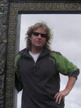

Thomas Kirchner



Born on March 7, 1964 in Osnabrück. Taijiquan (Tai Chi Chuan) teacher and trainer in the Taijiquan and Qigong network Germany, as well as in the DDQT (German umbrella organization for Qigong and Taijiquan). Instructor of the School of Central Balance. Judo from 1971-1988 in Osnabrück. Ibrium. Judo from 1971-1988 in Osnabrück. Taijiquan since 1990 with various renowned teachers and schools, but mainly with Mr. Wee Kee Jin (Auckland). Fujian Baihequan (White Crane Fist) with Mr. Wee Kee Jin. Further training at the Gauting Institute for Youth Work from 2003 to 2005 as a Budo teacher. www.tokitaichi.de

**Hella Ebel**

Hella Ebel, teacher and trainer (DDQT) for Taijiquan, has been practicing Taiji since 1983. Since 1997 she has been intensively trained by Wee Kee Jin in the system of Huang Sheng-Shyan, whom she has been assisting in Europe for many years. Understanding and applying the Taiji principles in form and partner work is always the focus. From the creative work as a craftswoman (goldsmith) with her own studio and Taiji lessons on the side, the development went to her own school in Osnabrück, a supra-regional place of learning and encounter.

[**http://www.hella-ebel-taiji.de/**](http://www.hella-ebel-taiji.de/)

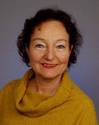

**Fixed - Pushing Hands:**

There are 18 fixed partner exercises in Master Huang's exercise system.

Two of the most important of these are 7 pushes and slow push. We will work on these and neutralization exercises.

With the fixed partner exercises and the semi-free pushing we have a good opportunity to get to know and study the inner principles.

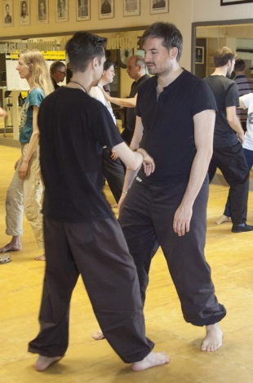 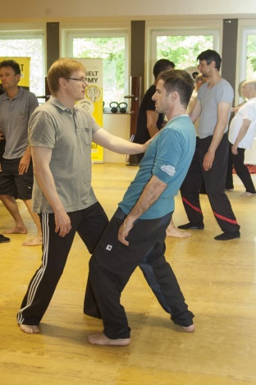 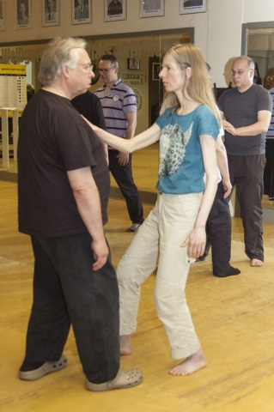

**Semi-Free Pushing Hands:**

What does that mean:

In semi-free pushing hands, it is stipulated that one tries to throw the other off balance while the partner only tries to neutralize it without pushing himself.

This gives me the certainty that I can fully engage in my part of the pushing hands. The one pushing can concentrate fully on throwing the partner off balance (observing principles from the classical Taiji scriptures, which are e.g.:

I don't use brute force, break the root first before thrusting...

The one who neutralizes has the opportunity to practice all the inner principles of the 5 elements.

By sticking, connecting, sticking, following, not offering any resistance and not loosening the connection, the yielding develops and any incoming force can be neutralized.

The advantage of semi-free pushing is that you learn to hear and feel how your partner behaves. Winning is a minor matter as both partners switch roles after 5 minutes.

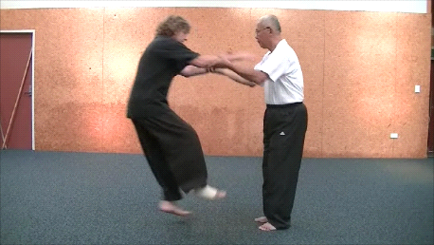 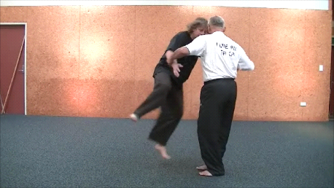

**Semi-free and free Pushing Hands are only performed in this meeting in a fixed position.**

The stand is changed every 10 minutes:

from the V - stand to the shoulder-width parallel stand and to the bow stand.

A signal sounds every 10 minutes to change partners and positions.

What is special about this type of pushing are the three positions in which it is performed.

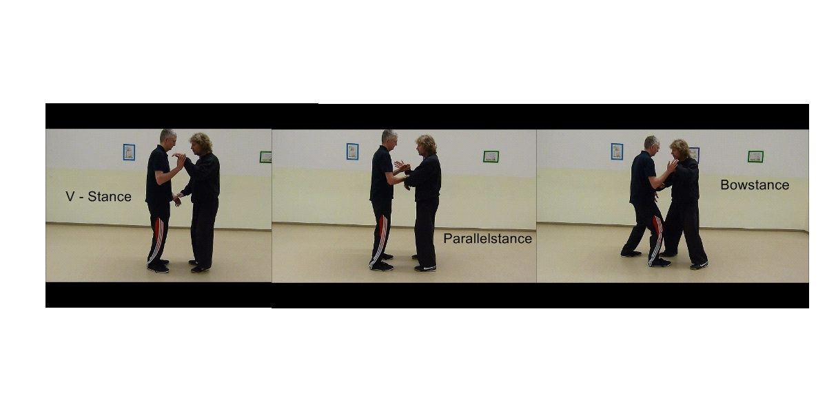

**V - stand:**

This means that the heels touch and the stance forms a V.

**Parallel stand:**

That means your feet are parallel, shoulder-width apart.

**Bow stand:**

This means: the back foot is rotated 45° and the front foot is about a foot length shoulder width forward parallel to the front foot of the partner.

**Free - Pushing Hands:**

In free pushing, both partners have the opportunity (observing the Taiji principles) to throw the partner off balance and to push.

Free - Pushing Hands mean:

Feel when your exercise partner loses his balance. Feel when he can no longer neutralize forces. When you feel this, relax and sink, strengthening your stability to completely break the partner's root. Now push with relaxed strength.

**Venue:**

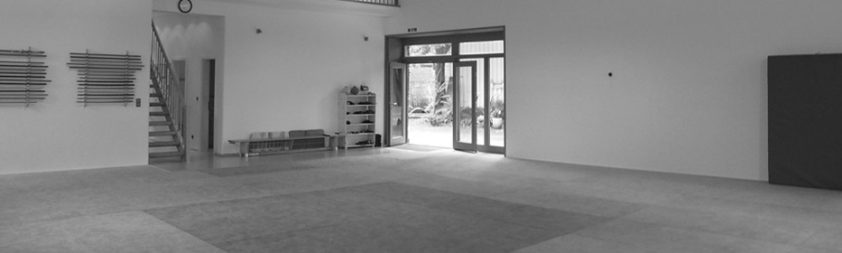

**Tai Chi Schule Hella Ebel** Liebigstr. 25 49074 Osnabrück

**Directions:** <http://www.xn--aikido-osnabrck-cwb.de/src/Kontakt.php>

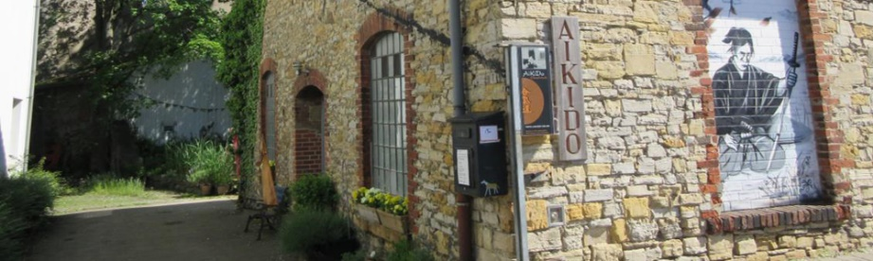

**Overnight stay:**

In Osnabrück and the surrounding area there are numerous accommodations (many holiday apartments, small hotels or guesthouses). The school is located just a few minutes´ walk from the city center, near the old town train station.

It is also possible to spend the night at the school with a sleeping bag for €5.00 per night. Showers are available.

**If you have any questions, please email me or just give me a call.**

T**ai Chi Schule Osnabrück - Hella Ebel**  
Liebigstr. 25  
49074 Osnabrück

Homepage: <https://hella-ebel-taiji.de/> E-mail: hella@taiji-schule-os.de  
Phone: +49 (0)541 4096987 Cellphone: +49 (0)152 0511 5312



**Registration**

A Registration by email is required. (Please also print out this registration form and send it in or bring it with you to the meeting) Thank you 😉

Surname: First name: ________________ ___ __

Street: _____________________________________________ ______ ___

Zip: City: __ _________________ __________ ___

Phone.: ________________________________________________ __ __ ___ _

E-Mail: _________________________________________________ __ ___

**Thursday til Sunday (200,- €)**

1 day 55,- €

2 days 105,- €

3 days 155,- €

4 days 200,- €

The days can also be booked individually!

**(please tick)**

I will come on the following days:

Thursday: **O** Friday: **O**  Saturday: **O** Sunday: **O**

I will pay the amount of…………Euro in cash at the beginning: **O**

I have transferred the amount of..............Euro to the account of Hella Ebel

IBAN: DE75 2659 0025 0309 3727 00 Volksbank Osnabrück: **O**

I need a receipt: **O**

Film and photo recordings will be made at the event and by signing the registration I expressly agree to being filmed and to the producers being allowed to publish and commercially exploit these recordings. I leave the rights to my own picture to the producers of the recordings free of charge.

I take part in the meeting on my own responsibility. No liability can be accepted in the event of accidents.

Place, date: ______________________ Signature: _________________________