Taiji Camp at Hesselberg from April 25 to May 2, 2027

Dear Taiji Practitioners,
Since Wee Kee Jin will no longer be coming to Europe to teach, Roland von Loefen and Hella Ebel would like to continue offering the intensive training camps at Hesselberg. Hella will take over the April camp, and Roland will lead the September camp.
We warmly invite you to the week-long Taiji seminar with Hella Ebel at Hesselberg. Christine Bench will assist this time. Therefore, beginners in the Huang system or your students are very welcome.
The workshop program includes the 5 loosening exercises of Huang Sheng Shyan, Taiji forms, and partner work. The sword form will also be covered this time. Please bring swords if you want to train with them. There may also be an alternative option available.
Early registrations have become necessary. Rooms can now only be canceled without cost up to 6 months before the course starts. That's why there's an early bird discount if you register by 19.10.26. The venue charges a hall rental fee, which is where the 60 € hall rental comes from. The course fee can be transferred to my account or brought in cash. The workshop starts on Sunday with dinner and ends the following Sunday with lunch.

Timetable:

6.00 – 7.00 Free Training

7:00 – 8:00 Free Pushing Hands

8:00 Breakfast

9:30 – 11:30 Lessons

12:00 Lunch

16:00 – 18:00 Lessons

18:00 Dinner

19:00 – 21:00 Lessons

We need a filled and signed registration form from each participant! Please send this to Hella via e-mail: hella@taiji-schule-os.de
or by post: Hella Ebel, Natruper Strasse 6, 49076 Osnabrück
Location of the Evangelical Education Center and how to get to the Hesselberg:

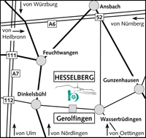 | 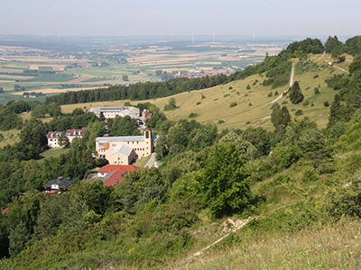
The Evangelical Education Center is in a secluded location on the Hesselberg. The adress is:

Evang. Bildungszentrum Hesselberg
Hesselbergstr. 26
91726 Gerolfingen

There is a day café and an indoor pool in the complex. The indoor pool can be used free of charge by course participants.
At 689 m, the Hesselberg is the highest peak in Middle Franconia. As a witness of the Franconian Jura mountain Hesselberg is the geographic center between the Romantic Road, the New Franconian Lake District, Nördlinger Ries and the rococo town of Ansbach.
Arrival by car: A6 exit 52 (Ansbach/Wassertrüdingen)
A7 exits 111 (Feuchtwangen) or 112 (Dinkelsbühl)
Then orient yourself towards the towns of Wassertrüdingen and Dinkelsbühl.
The training center is located above the village of Gerolfingen.
The way up to Hesselberg is only possible from there.
In Gerolfingen - on the state road 2218 between Wassertrüdingen in the east and Dinkelsbühl in the west - clear signs point the way to the Evang. Education Centre. There is no direct connection by public traffic. The nearest train station is Gunzenhausen.
It is possible to be picked up from the Evangelical Education Center at Gunzenhausen train station for 15€. If necessary, please contact the training center in advance.

Further information on the Evangelisches Bildungszentrum Hesselberg can be found on the following page: https://ebz-hesselberg.de

Registration form

I hereby register for the Taiji workshop with Hella Ebel Jin from April 25th to May 2nd of 2027 at Evangelisches Bildungszentrum Hesselberg.

Surname | First name
Street, house number | Postal Code, city
Telephone | E-mail

I have the following room request:
Single room with shower/toilet 102,50€ per day – 717,50€ week.
Double room with shower/toilet 95,50€ per day – 668,50€ week per person.
Name of the room partner if you wish to have a double room:

Meals |  | vegetarian |  |  | meat

The course fee for the lessons is: |  | €

For a shorter participation of the workshop, 15 € per lesson (with 6 lessons/day to be paid) will be charged. With an early bird discount of 14 € per lesson and, if possible, a reduction in the hall rent. If staying only one night an extra fee of 10€ is to be paid.

A fee of 5 € is required for an individual billing of the accommodation for the tax office.

An early booking discount is only available with a binding registration (signed) and a transfer of €60 for the hall rental by Oktober 19th to the following bank account:
Hella Ebel
IBAN: IBAN: DE75 2659 0025 0309 3727 00
BIC: GENODEF1OSV
Early bird 440€ course fee later 480€

I take part in the workshop on my own responsibility and in good health. No liability is provided in the event of accidents. Attendees participate on their own risks.

Place, date | Signature

